Parents or Guardian’s Notice of No Liability Insurance and Acknowledgement
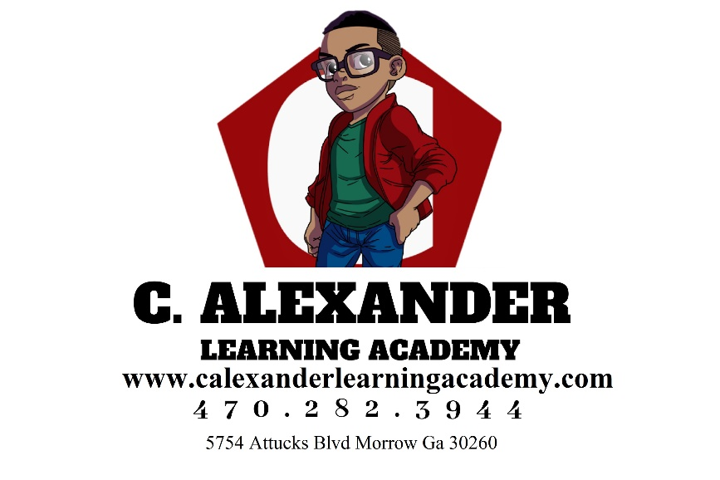

I understand that I am being informed in writing by signing this acknowledgement that this facility, C. Alexander Learning Academy, does not carry liability insurance sufficient to protect my children in the event of an injury, etc.

____________________________________ _______________
Parents or Guardian’s Signatures Date
____________________________________ _______________
Parent or Guardian (Print Names) Date
__________________________________ _______________
Center Director’s Signature Date

